Developing learners’ collaborative problem solving skills

Patrick Griffin & Esther Care
Assessment Research Centre, Melbourne Graduate School of Education
(November, 2014)

Objectives:

Explore the nature of collaborative problem solving.

Differentiate group work and collaborative group work

Set guidelines for developing collaborative projects or problem resolution

21st century framework and skills
What are the capabilities that have been identified and defined as 21st century skills? One view is that any skills that are essential for navigating life in the 21st century could be classed as 21st century skills. This does not mean that many familiar skills of the 20th and preceding centuries are no longer needed. But there are new skills emerging as increasingly important. In this session we will provide an overview of how several global initiatives have looked at skills within a 21st century framework. Because of the recent decision by the OECD to focus collaborative problem solving.
Skill, competence, competency - which are we talking about? Well, different groups conceptualise these notions differently! Some initiatives are based in an understanding of the school curriculum. They define competence as something that goes beyond physical and cognitive aspects to include attitudinal characteristics, and assume that these are essential to assure a successful life and society. Others, like the ATC21S project maintains use of the term "skills" but effectively also encompass attitudinal characteristics. For our purposes in the ATC21S project, we regarded a skill as an action a person can perform. Competence encompasses the quality and transferability of that action over time and context. No one performs a skill at the same level every time. No one operates at their maximum all the time. We adjust our performance according to the demands at the time. Competence therefore can be regarded as the ability of the person to adjust the skill performance to the demands of the context.

The c21 skills framework
The ATC21S project began in 2009 and one of the first questions was to do with the definition and framework and because technology had made changes to the workplace and life styles, new skills were needed as well as new emphases on older skills. In order to deal with this a symposium held at the end of the AERA conference in San Diego recommended four sets of skills be recognised as essential for adjustments to the effect of technology on life, learning and work. The skills were identified as those which would enable people to demonstrate new ways of thinking, ways of working, tools for working and living in the world that had emerged as a result of technology.

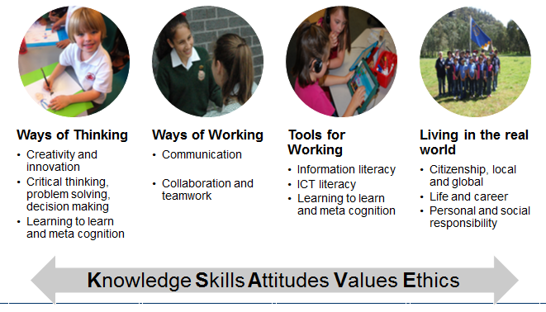
Figure 1: the KSAVE Framework for ATC21S

\Ways of thinking were conceptualised to include creativity and innovation, critical thinking, problem-solving, and learning to learn and the development of metacognition. Ways of working was conceptualised to include communication, collaboration and teamwork; Tools for working involved information and ICT literacy; Living in the world involved changing emphases on local and global citizenship, aspects of life and career development, and personal and social responsibility. These were all grouped under the acronym KSAVE: knowledge, skills, attitudes, values and ethics. It also meant that the Ways of learning and ways of teaching need to be taken into account in the development of the assessment strategies that focus on these skills.
As we all know, the 21st century does not exist in isolation! Two initiatives indicate that the concerns began in the 20th century – those undertaken by UNESCO and PISA. These provide a context for teaching and assessment in the 21st century skills arena. UNESCO recommended a competence approach. The Delors’ Report (1996) marked the beginning of UNESCO's 21st century competence learning discourse - with learning to know, learning to do, learning to be, and learning to live together - forming the four pillars of learning. These four pillars are more complex than appears and shift the discussion somewhat to a philosophical level.
Learning to know includes developing the faculties of memory, reasoning and problem solving; it pre-supposes learning to learn and could usefully be extended to the concept of knowledge building. This perspective does not presume that knowledge is fixed. Learning to do implies acquisition of complex skills, but also refers to developing an aptitude for teamwork and initiative, and a readiness to take risks. Learning to live together is the pillar UNESCO emphasizes more than any other. It refers to developing an understanding of others as well as highlighting the reality that if we are to understand others, we must first know ourselves. Learning to be is founded on the fundamental principle that education needs to contribute to the all-round development of each individual. This pillar deals with what it is to be human, comprehended by intellectual, moral, cultural and physical dimensions.
The OECD's position, developed within the DeSeCo Project - Definition and Selection of Competencies - has a focus on key competencies - and classifying these competencies in three broad categories. First, individuals need to be able to use a wide range of tools for interacting effectively with others and the environment. They need both physical tools such as information technology and socio-cultural ones such as the use of language. They need to understand these tools well enough to adapt them for their own purposes. Second, in an increasingly networked and interdependent world, individuals need to be able to engage with others. Third, individuals need to take responsibility for managing their own lives through situating themselves in the broader social context.

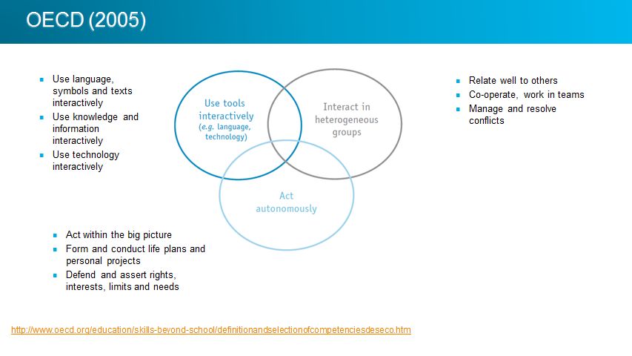
Figure 2: UNESCO Synthesis of Needed Skills

Partnerships 21 took as their mission to catalyse US K12 education for the 21st century. Essentially they endorse the "fusing" of traditional academic disciplines with skills including critical thinking, communication, creativity, and collaboration - the 3Rs with the 4Cs; these are contextualised within life and career skills, and technology and media skills.

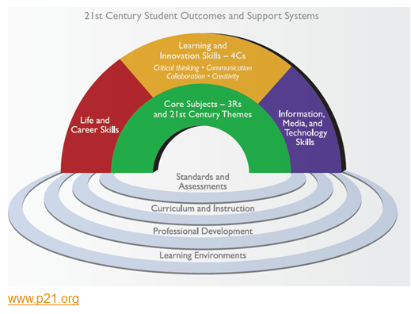
Figure 3: Partnerships 21 Curriculum Framework

Each of the approaches to understanding of 21st century skills and how they fit with our notions of education and the function it serves, emphasises skills that diverge from modern traditional notions of academic disciplines. They all actually identify enabling skills - skills that we need to navigate our global society. They converge on a common set of 21st century competences - collaboration, communication, ICT literacy, and social and/or cultural competencies; and most include creativity, critical thinking, productivity, and problem-solving.

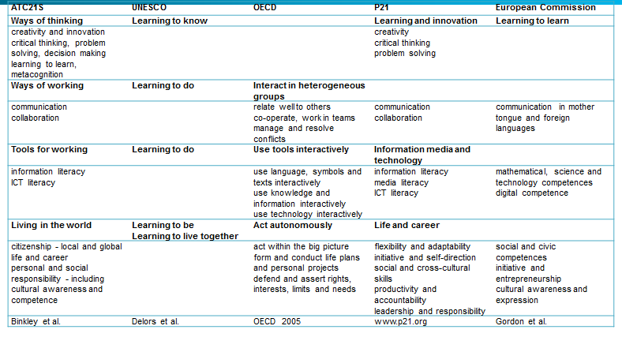
Figure 4: Comparisons of organisations defining c21 skills

Notwithstanding the strong degree of agreement across the initiatives, they are all developed at the conceptual level and they differ in terms of what they set out to achieve. The P21, European Union, and OECD's DeSeCo frameworks can be regarded as generic frameworks that provide a conceptualization of 21st century skills upon which other frameworks can be built. Areas most in need of explicit development and application are those associated with teacher development, curriculum, and assessment. Within the ATC21S framework work has focused on a two complex skills areas in order to look at precisely these issues - of teaching and assessment, and their implications for the curriculum. In this session we will focus on just one of them – collaborative problem solving.
Collaborative problem solving is a complex skill requiring both social and cognitive competencies. It was rationalised by the ATC 21S project team as a composite skill arising from the links between critical thinking, problem solving, decision making and collaboration. The term “collaborative Problem Solving” was adopted from the work of O’Neill (2014) and from counselling in the work of Green (2004). Hesse et al (2015) conceptualised collaborative problem solving as consisting of five broad strands - participation, perspective taking, social and task regulation, and knowledge building and we will return to these in detail. These strands have been used as the framework for the development and field testing of scenario-based tasks designed to elicit collaborative problem solving skills. Collaborative problem solving is a set of skills that we need to rely on when the capacities or resources of just one person are not sufficient to solve the problem. We need to learn how to combine different resources and skills when faced with complex problems. The OECD has also adopted these approaches, with a slightly different interpretation and conceptual framework and will assess collaborative problem solving in 2015 PISA study.

Figure 5: Two Domains of Collaborative Problem Solving

The challenge for teachers in scaffolding student learning in collaborative problem solving, is to identify students’ emerging skills and provide the right support at the right time at the right level. Teachers’ assessment practices have to adjust and move from generating summative information about past performance, or as comparison of one student with others, toward assessment that helps them find the starting point for instruction and ways in which they can tailor their teaching to students learning social and cognitive skills associated with collaborative problem-solving. This is the heart of formative assessment. It links assessment and teaching and in this course it links assessment and teaching to 21st-century skills.

The Nature of collaborative problem solving
The primary distinction between problem-solving by an individual and collaborative problem-solving is its social nature - the need for communication, exchange of ideas, shared identification of the problem and its elements, and negotiated agreement on connections between problem elements and relationships between actions and their effects. Collaborative problem-solving makes each of these steps observable, as they must be shared with a partner or other members of a group if a solution is to be successfully identified. These steps can be described as follows:
- A problem state must be jointly recognised, and collaborators must identify and agree on which elements of the problem each can control or monitor.
- A representation of the problem must be shared.
- Collaborators need to agree on a plan of action, including management of resources.
- Plans must be executed, which may require a coordinated effort by collaborators acting together or in sequence.
- Progress towards a solution must be monitored, different options evaluated, plans reformulated if necessary, and collaborators must decide on how to proceed in the face of positive or negative feedback.
This approach to problem-solving has been described in the literature since 1973, when Polya formalised it as a way to solve mathematics problems. It has since been adopted in the maths and science related problem solving tests of the OECD’s PISA international studies. ATC21S has taken the view that this might not be appropriate for collaborative problem-solving in areas broader than mathematics and science. Collaborative problem solving can incorporate social and historical problems as well as mathematics and science, for instance. Table 1 provides a summary comparison of the different approaches taken to problem-solving and collaborative problem-solving by Polya’s (1973) approach, the OECD’s PISA studies, and ATC21S.

Polya 1973 | PISA 2003/2012 | ATC21S
Understand the problem | Explore and understand | Collect and share information about the collaborator and the task
Devise a plan | Represent and formulate | Check links and relationships , organise and categorize information
Carry out the plan | Plan and execute | Rule use: set up procedures and strategies to solve the problem using an “If, then..” process
Look back and check | Monitor and reflect | Test hypotheses using a “what if” process and check process and solutions
Table 1: Comparisons of approaches to problem-solving and collaborative problem-solving.

In the ATC21S study, problem-solving was seen as a series of steps leading towards hypothesis testing and collaborative testing of ideas:
- The first step is where each of the individuals within the collaborative team explores the problem space and identifies the elements and aspects of it. They might record their observations individually at this stage.
- The next step involves students collecting and sharing information about problem elements and how they link together. In this process the students are identifying and collating the total amount of information about the problem by sharing information about observations and collaborating and defining the problem space.
- Discussion then centres on whether there are patterns and links between elements of the problem, both within and across the areas of observation available to each of the participants.
- Once the connections are identified, the discussion and collaboration begin to formulate rules or contingencies associated with actions and observations. These need to be shared across the participants’ observation space. The discussion follows the “if… then” paradigm.
- By a process of observation and collecting data about the link between actions and observations, the collaborators then begin to formulate rules or contingencies. These lead to generalisations so that the collaborators can conclude that every time a particular action takes place a particular consequence is observed. At this point they move from inductive to deductive reasoning in the hierarchy of problem solving skills.
- At the highest ATC21S level of performance, students reflect on the kind of conclusions that are drawn from the information about exceptions to the generalisations. At this point the students are testing hypotheses by challenging generalisations. They address the issue with such expressions as "what if…"
The importance of collaborative problem-solving in the workplace is increasing as societies and workplaces become increasingly knowledge dependent. Collaborative problem solving requires that the people combine their resources and their strategies in order to reach a common goal. The assumption here is that collaboration is essential because the task is too complex for a person to work through it alone. It may be that different people possess different information; different expertise and experience that they can bring to the problem space in order to jointly share the knowledge, experience and strategies in order to jointly solve a particular problem. So combining resources is important. So too is the knowledge and the kinds of skills that each person possesses. So we would argue that collaborative problem-solving has these two main components. The collaborative, sharing or social aspects and the knowledge, strategic, problem-solving or cognitive aspects.
Collaborative problem solving is therefore defined as a joint activity where two or more people work together to contribute knowledge, skills, materials and procedures and move through a series of cognitive states that involve collection and analysis of information and the formulation of hypotheses that they jointly set out to test.
There has been, and possibly will continue to be, a debate about the nature of collaborative problem solving, methods defining it and the concern that measuring it might distort its nature. In the ATC21S project collaborative problem-solving was measured by developing algorithms that monitored and logged the kinds of activities and communications that a pair of students shared when they were jointly setting out to solve a problem.
We explored a different approach to assessment. Traditionally when collaborative teams undertake assessment tasks, problem based learning projects, or investigations in the classroom, the assessment focuses on the outcome of the team effort. We now examine how we can identify individual skill development and their contribution to the overall team result. This is what makes the measurements of collaborative problem-solving different from almost every other group problem solving, or collaborative learning approach. The second thing that makes it different is that it is technology-based. Just reviewing a couple of simple examples of two people working their way through a particular collaborative problem solution it becomes evident that an observer gets lost in the complex interactions and activities of the participants.
The medium of delivery of the task or project can be face-to-face or through technology. With technology there is a range of ways in which the students can collaborate. This can be across different countries, classrooms and it does not matter if there physically separated by times, location, page, opportunity or subject knowledge. What is required is that the students can simultaneously access the tasks and interact with one another via the Internet to explore potential procedures and strategies that would help them solve a complex problem. The essential aspect of the collaborative problem-solving task or a collaborative problem based learning project is that each participant in the group possesses or controls unique knowledge, expertise, experience, materials or objects that are essential to the completion of the task, the project or the problem solution. Without every individual contributing their specific resource project cannot be completed; problem cannot be solved; the task cannot be done. Collaborative problem-solving demands that every participant contributes to the work of the group and is able to understand and explain to their collaborators their role and the importance of their contribution to the solution of the task.
So it is clear that collaborative problem-solving relies upon at least two areas of skill. The students working together must have the capacity and skills that enable them to work collaboratively and to share their knowledge, expertise and suggestions of strategy. They must also have the cognitive skills that enable them to understand the problem and analyse its tasks and specific requirements. In addition the student will need to have the cognitive skills that will enable them to assemble information; build their expertise and understanding of the problem; link their shared understandings to particular procedures that will enable them to make progress in reaching the problem solution and to be able to identify patterns and strategies that can help understand connections and contingencies that will eventually enable them to make generalizable suggestions to each other about problem solution and to test those generalisations in the form of hypothesis testing.
So in designing a collaborative problem based task or project there are several steps:
- Define the problem or collaborative project.
- Identify project elements and components in detail;
- for each component identify the resources that are essential. These can be;
  - knowledge
  - materials
  - strategies
  - experience
  - equipment;
- Allocate to each participant non-overlapping, unique sets of resources necessary to be contributed to the project completion or problem resolution. Divide the resources amongst the participants with no shared or common resources.
- Clearly state the goals of the task or problem solution and observed to students procedure in the task.
- Explain to the participants that they must identify the problem, sort out a strategy to resolve the problem or complete the task
- The students also need to develop a means of keeping records of their decisions and discussions. For face-to-face attempts at collaborative problem-solving or collaborative project work keeping records is an essential aspect of the assessment process.

References
Autor, D., Levy, F., & Murnane, R. (2003). The skill content of recent technological change: An empirical exploration. The Quarterly Journal of Economics, 118(4), 1279–1333.
Binkley, Marilyn, Ola Erstad, Joan Herman, Senta Raizen, Martin Ripley,May Miller-Ricci, and Mike Rumble. Defining Twenty-First Century Skills in Griffin, P. , McGaw, B., and Care, E., (2012). Assessment and Teaching of 21st Century skills. Springer. Dordrecht.
Care, E. , Griffin, P., Claire Scoular, C., Awwal, N & Zoanetti (2015). Collaborative Problem Solving Tasks in Assessment and Teaching of 21st Century Skills. Methods and Approach (Eds) P. Griffin, & E. Care. (2015) Springer. Dordrecht.
Delors, J. (1996 ) Learning the treasure within; Education: the necessary Utopia: Report to UNESCO of the International Commission on Education for the Twenty-first Century. Paris: UNESCO Publications .
Gordon, Jean and Halász, Gábor and Krawczyk, Magdalena and Leney, Tom and Michel, Alain and Pepper, David and Putkiewicz, Elzbieta and Wiśniewski, Jerzy, Key Competences in Europe: Opening Doors for Lifelong Learners Across the School Curriculum and Teacher Education (2009). CASE Network Reports No. 87. Available at SSRN: http://ssrn.com/abstract=1517804 or http://dx.doi.org/10.2139/ssrn.1517804
Greene, R.W. et al. (2004) Effectiveness of Collaborative Problem Solving in affectively dysregulated youth with oppositional defiant disorder: Initial findings. Journal of Consulting and Clinical Psychology, 72, 1157–1164
Griffin, P. & E. Care. (2015). Assessment and Teaching of 21st Century Skills. Methods and Approach (Eds) Springer. Dordrecht
Griffin, P. (2014). “Performance Assessment of Higher Order Thinking.” Journal of Applied Measurement. 15 (1): 53-68
Griffin, P. Mak, A. and Wu,M. ( 2006) Interactive problem solving skill and assessment. Australian Research Council Linkage Project.
Griffin, P., B. McGaw & E. Care Assessment and Teaching of 21st Century Skills. (Eds). Springer. Dordrecht
Griffin, P., Care, E., & McGaw, B. (2012) The Changing Role of Education and Schools. In Assessment and Teaching of 21st Century Skills. (Eds) P. Griffin, B. McGaw & E. Care. Springer. Dordrecht.
Griffin, P., Care, E., Harding, S. (2015)Task Characteristics and Calibration in Assessment and Teaching of 21st Century Skills. Methods and Approach (Eds) P. Griffin, & E. Care. (2015) Springer. Dordrecht
Jaimovich, N. and Henry E. Siu (2012). The Trend is the Cycle: Job Polarization and Jobless Recoveries NBER Working Paper No. 18334, Issued in August 2012. NBER Program(s):
Kilvert, P. (2001) Partnerships 21. International Education Journal Vol 2, No 1, 2001
O’Neil, H. (2014) Measurement of Collaborative problem Solving. NAEP Innovations Symposium, Sept. 29, 2014, Alexandria, VA
OECD (2012) Directorate for Education and Skills. Skills beyond school ; Testing student and university performance globally: OECD’s AHELO .
Parson, F. (1909) Choosing a Vocation. Boston: Houghton Mifflin Co., 1909. —Posthumously published.
Polya, G. (1973). How to Solve It, Princeton University Press: Princeton, NJ.
Seidman, D. (2014) From Knowledge Economy to Human Economy. Harvard Business Review, November 12, 2014.
Zoanetti, N. P. (2010). Interactive computer based assessment tasks: How problem-solving process data can inform instruction. Australasian Journal of Educational Technology, 26(5).

Polya, G. (1973). How to Solve It, Princeton University Press: Princeton, NJ.

